# 7 CS 5551 ADVANCED SOFTWARE ENGINEERING SP 2016

PROJECT GROUP 7

Student Companion

|  |
| --- |
| User Manual  Students in modern times use different mobile applications not just for entertainment but for studying as well. We have developed a student friendly mobile application which can assist them in completing their tasks on time. |

Contents

Introduction 1

Setting Up 2

Device constraints 2

Sign Up 2

Login Page 4

Profile 5

Lab information 7

Reserve study room 8

Student Assistant Menu 13

Support 16

Deficiencies 17

INDEX 18

# Introduction

This guide is written for students who use Student Companion application. The application enables the students to login with their details and manage their tasks.

With this application you can:

* Create a profile with your personal information and keep your account secure with a password.
* View your class schedule and be informed about the tasks associated with the courses taken.
* Access lab information and know the availability of the systems.
* Reserve/Cancel a study room for a time slot using calendar view.
* View your shift schedule and can take any available shifts.

# Setting Up

Before downloading the app you must be a current enrolled student in UMKC. This gives you the access to login with your student sso details.

# Device constraints

The Student Companion Application supports devices on Apple iOS 8.0 or later and Android with connectivity from a wireless carrier or Wi-Fi provider. This can also be accessed through web browser.

# Sign Up

When you open the student companion app for the first time, you need to register from login page as shown below:

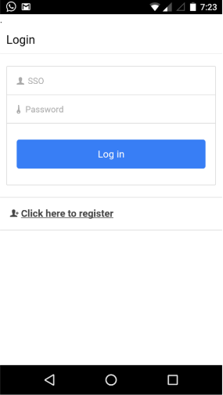

Click the register link, where you can complete your profile and register yourself to login into the app. All the details must be filled with correct information and choose a secure password with minimum of 8 letters. Then proceed to click register.

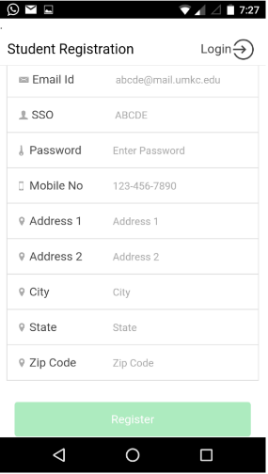

After successful registration you will be redirected to the login page.

# Login Page

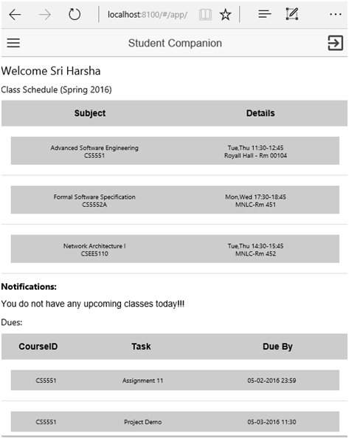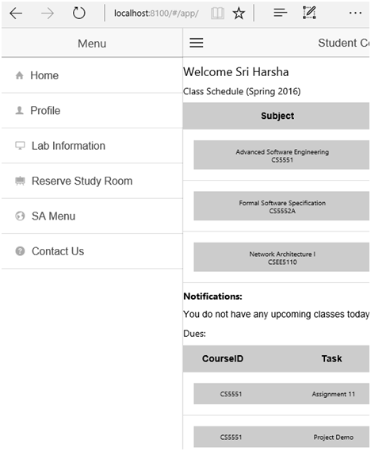Log-in to your account by giving your sso id and password. A home page pops up with a side menu, displaying your current class schedule and notifications.

**Fig: Home page**

**Fig: Side Menu**

Lets’ explore the different options we have in our side menu.

# Profile

The profile section has the complete information about you, which you have filled at the time of registration. It has the options to update profile information and your password.

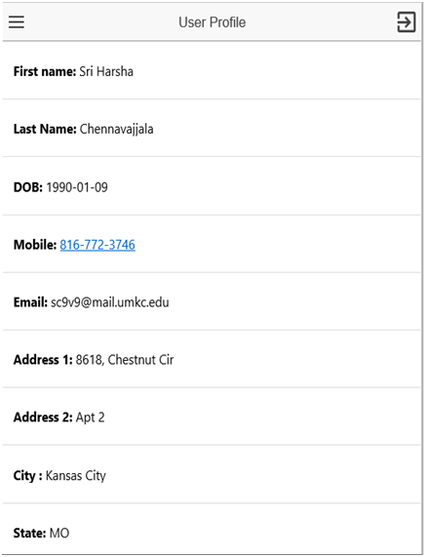

When there is a change in your personal details, you can click on “update personal info” tab and update your details.

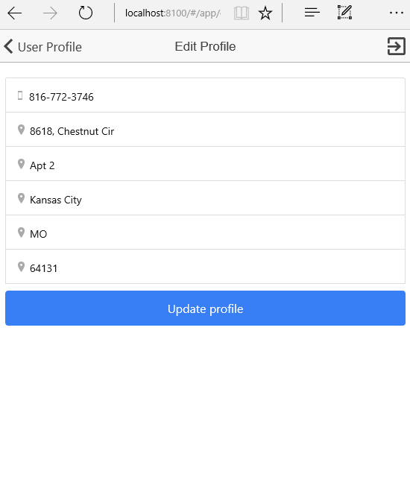

Periodic change of password is important to maintain the security of your account. You can change your password and keep it updated from the “change password” tab provided. To update the password the existing password must be entered along your new password.

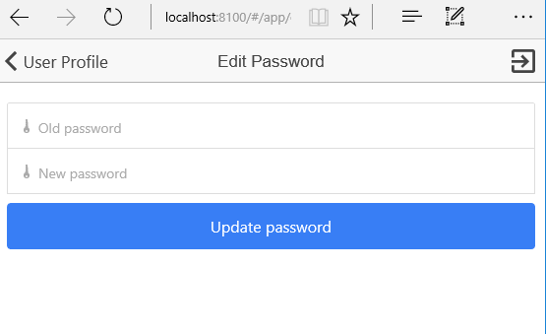

# Lab information

The labs information section shows you all the available labs in a list view. When you select a lab, you’ll see the details like location, capacity, working hours and reservations for next week.

**Fig: Lab information**

**Fig: Lab details**

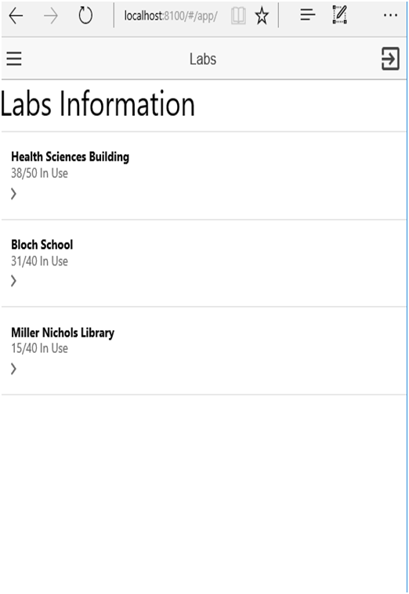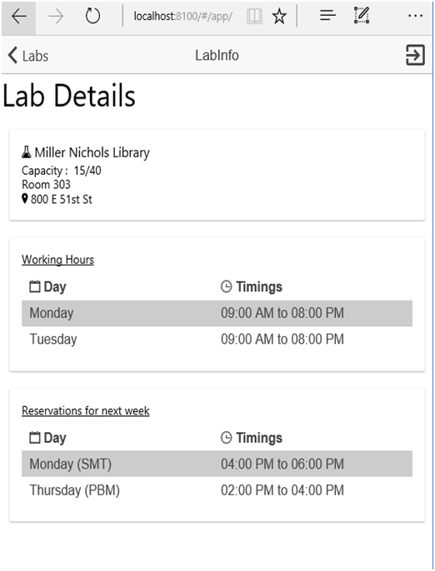

# Reserve study room

This section allows you to reserve a room for your group studies. You can view all your reservations from the “view my room reservations” tab.

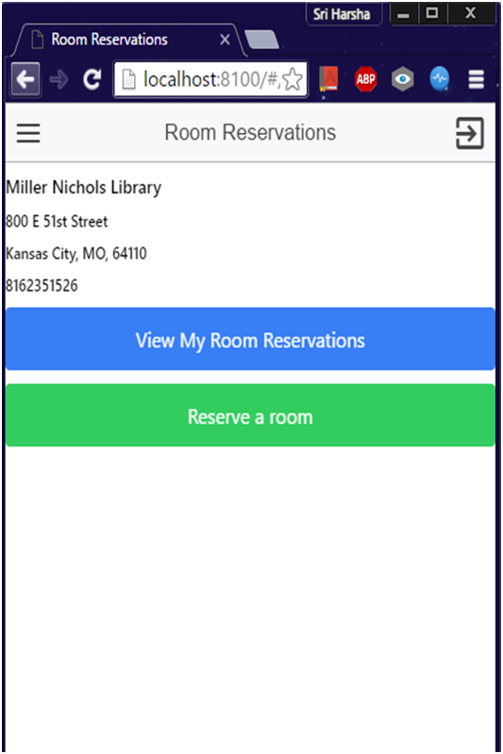

**Fig: Room reservations**

**Fig: My room reservations**

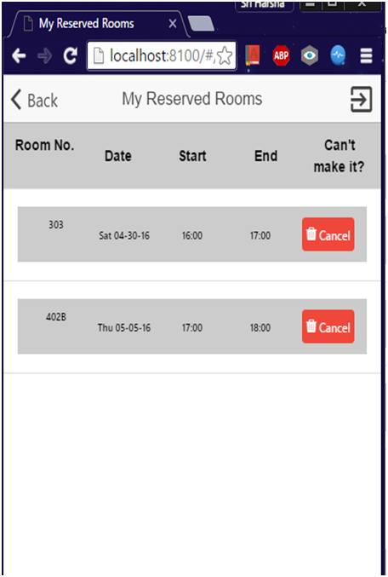

**To reserve a room:**

**Step 1:** go to reserve study room tab from the side menu

**Step 2:** click “reserve a room” option

**Step 3:** a list view appears with the available rooms. Click the select option

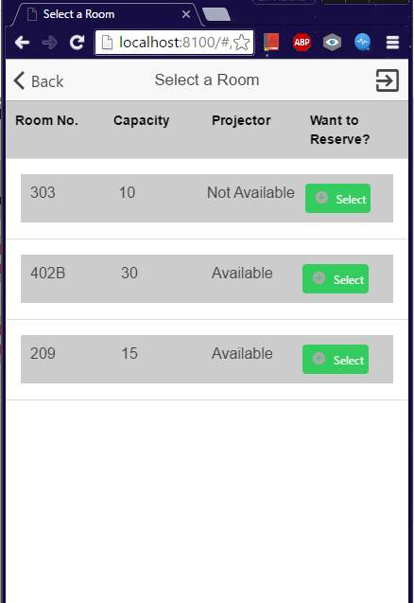

**Step 4:** a calendar opens to select the date

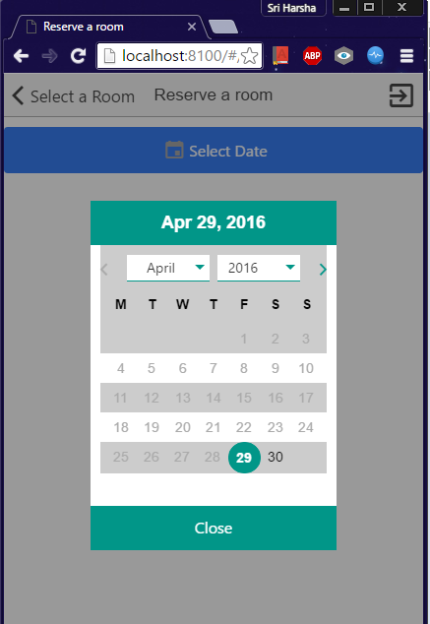

**Step 5:** a list of available time slots open for your selected date

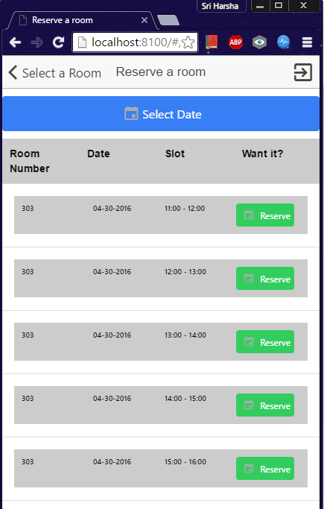

**Step 6:** click the reserve option for your desired time slot

**Step 7:** a confirmation page pops. Check your details and submit

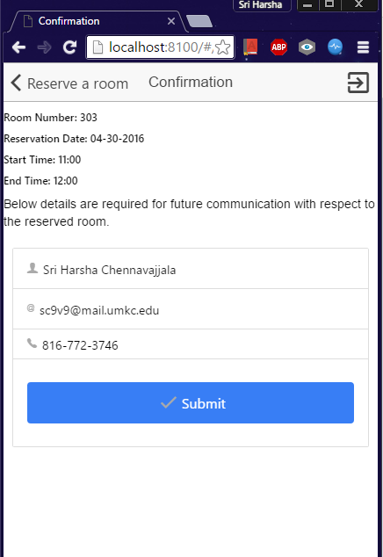

If there are any alterations in the schedule, the lab coordinator contacts you through mail.

**To cancel a room reservation:**

**Step 1:** go to “reserve study room” tab and click “view my room reservations”

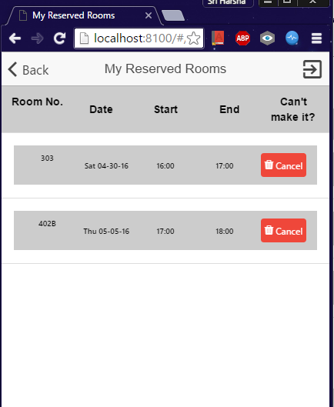

**Step 2:** select the cancel option for your desired time slot

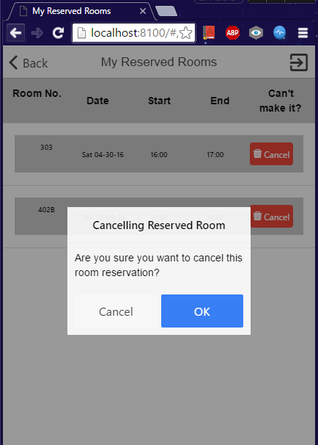

**Step 3:** click ok to confirm

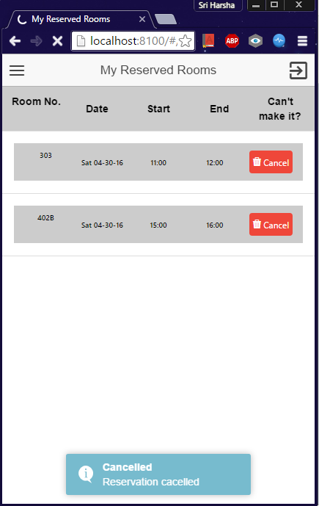

# Student Assistant Menu

Students who work for IS labs can see their assigned shifts in this section. If any substitution slots are posted, you can take those shifts by selecting the particular slot from the list.

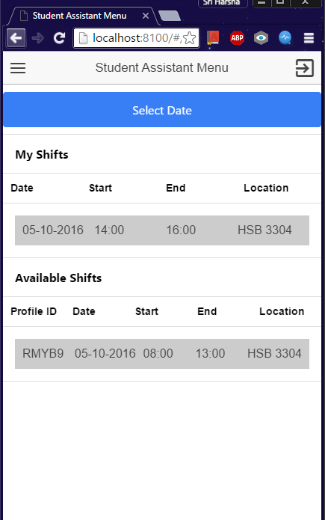

**To post shift:**

**Step 1:** go to “student assistant menu” tab

**Step 2:** select date

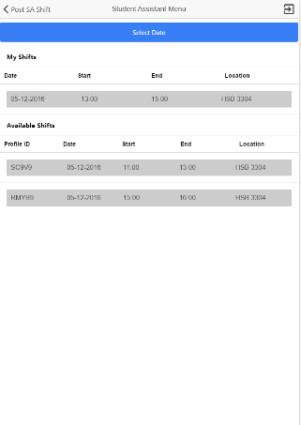

**Step 3:** enter the time and confirm.

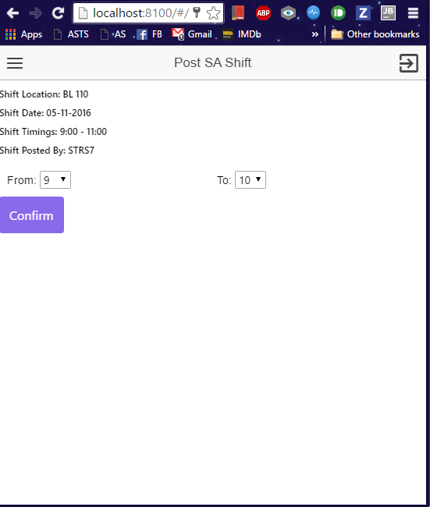

**To take shift:**

**Step 1:** go to “student assistant menu” tab

**Step 2:** select date and check for available shifts

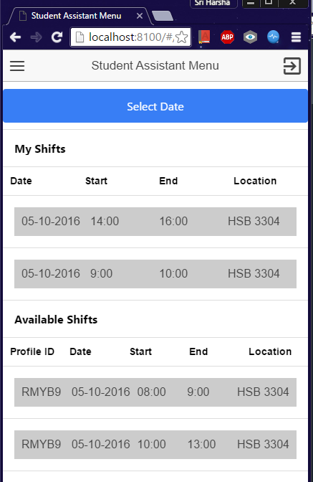

**Step 3:** select the time slot and click confirm

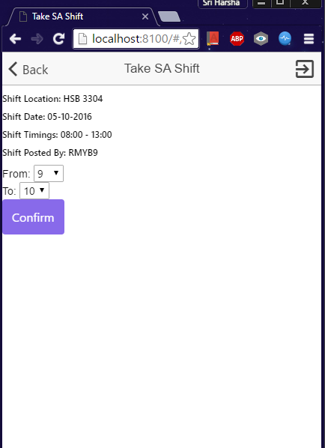

# Support

The section “contact us” has the details to contact the call center for any queries or problems.

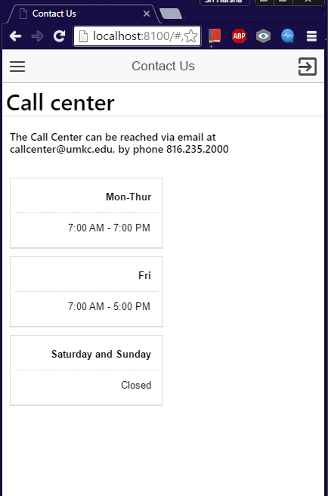

# Deficiencies

You cannot:

* delete your account
* add a profile picture
* add yourself to a waitlist for reserving a room

# INDEX

available labs, 7

**cancel a room**, 11

change password, 6

contact us, 16

Device constraints, 2

home page, 4

**post shift**, 13

**reserve a room**, 8

Setting Up, 2

side menu, 4

Sign Up, 2

**take shift**, 15

update profile, 5